**Travel Blog Website**

**Team Members:**

* Mohammed Mahmoud Atef
* Mohammed Hesham Munib
* Adullah Magdy
* Youssef Abd El Atty
* Omar Samy Mohammed
* Mohammed Gaber

**Project Index:**

1. First page (Home):

* Contain the contain the nav bar and footer of the web site and default posts that people already posted

1. Second page (Log in and sign up):

* Both of them the new people can access the web site if each one already has an account so he can sign up or not have an account so can log in to start share its post

1. Third page (Dashboard):

* This page it appeared weather the user accesses to the web site after login of signup

1. Fourth page (Destinations):

* This Page contains the different destinations that tourist visit it

1. Fifth page (Blog Posts):

* This page contains the posts that posts by the tourist that have a special experience when visit a specific destination

**The signature of the website and its importance:**

* Travel blog website where users can read and publish blog posts about their travel experiences.
* This idea helps for sharing the experience of the publisher where he travels the places that he visited, its advantages and disadvantages of his travel
* It’s look like a social media website that contains differences feedback and knowing more about the traveling sites that people can visit around the world

**The tools and programs that used through working on the website:**

* Oline AI and UI UX Design Websites (Uizird)
* Visual Studio Code
* UI and UX Design
* HTML 5 Hyper Text Markup Language
* CSS 3 Cascading Style Sheeting
* Bootstrap Framework
* Java Scripts scripting language
* Angular Framework
* Type Script
* Responsive to all devices Desktop, Tablet, and Mobile

***Home Page***

***Blog Posts Page***

***Login Page***

***Signup Page***

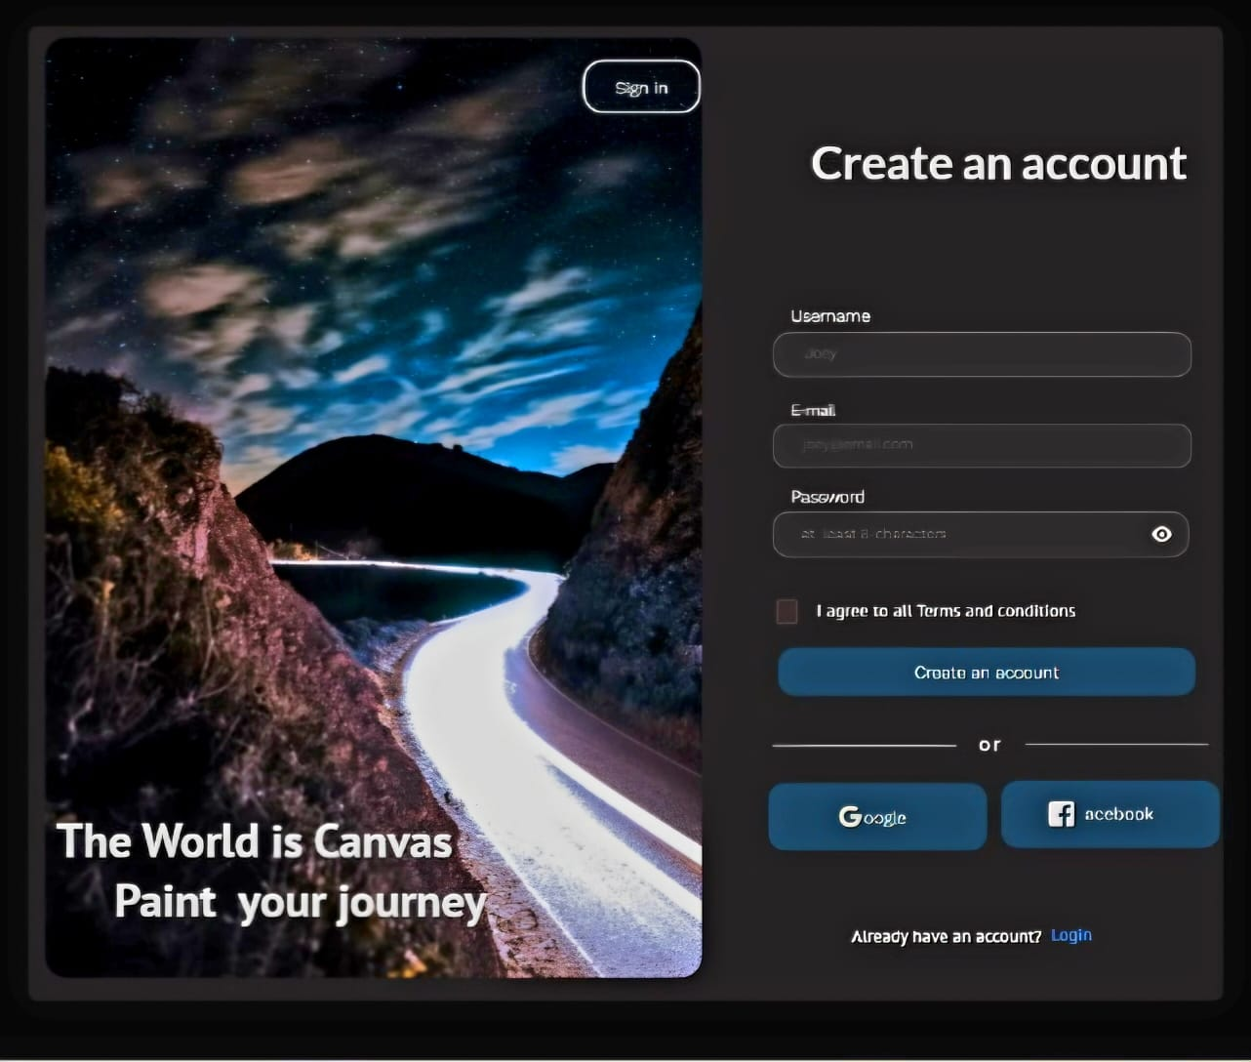

***Destinations Page***

**The work of each person in the team:**

* Mohammed Hesham Munib Mohammed
* Home Page
* UI and UX design and Wireframe
* Documentation of the project
* Mohammed Mahmoud Atef
* Blog posts
* Youssef Abdelaty
* Login and Signup
* Routing of the website
* Mohammed Gaber
* Dashboard
* Omar Samy and Abdalla Magdy
* Destinations

***Case Study of the Project***

**Project Overview**

**Client:** A seasoned traveler looking to share their adventures and experiences through a personal travel blog.

**Goal:** To create a visually appealing and user-friendly website that showcases the traveler's blog posts, allowing visitors to easily explore different destinations, read detailed articles, and engage with the content.

**Technology Stack:** Angular, HTML, CSS, JavaScript, Bootstrap (for responsive design).

**Development Process**

**1. Requirements Gathering and Planning:**

* **Understanding the Client's Vision:** In-depth discussions with the client to determine their desired features, aesthetics, and overall website goals.
* **User Persona Creation:** Defining the target audience (e.g., fellow travelers, adventure enthusiasts) to tailor the website experience accordingly.
* **Wireframing:** Creating basic visual representations of the website's layout and structure to establish a foundation for design and development.

**2. Front-End Development:**

* **Setting Up the Angular Project:** Initializing a new Angular project using the Angular CLI, configuring necessary dependencies and modules.
* **Component Structure:** Breaking down the website into reusable components (e.g., header, footer, navigation, blog post card, blog post detail page).
* **Templating with HTML:** Using Angular's template syntax to create dynamic and interactive HTML structures.
* **Styling with CSS:** Applying CSS styles to ensure a visually appealing and consistent look across the website, leveraging Bootstrap for responsive design.
* **JavaScript Logic:** Implementing JavaScript functionality using Angular's TypeScript to handle user interactions, data binding, and dynamic content updates.

**3. Data Integration (Optional):**

* **API Integration:** If the client has a backend API (e.g., for fetching blog post data), integrate it using Angular's HttpClient module to dynamically populate the website with content.
* **Data Modeling:** Creating data models to represent blog posts, destinations, and other relevant entities.

**4. Testing and Quality Assurance:**

* **Unit Testing:** Writing unit tests to verify the correctness of individual components and their interactions.
* **End-to-End Testing:** Conducting end-to-end tests to ensure the entire website functions as expected from a user's perspective.
* **Cross-Browser Compatibility:** Testing the website on different browsers and devices to guarantee a consistent experience.

**5. Deployment:**

* **Hosting:** Choosing a suitable hosting platform (e.g., Netlify, Vercel) to deploy the website.
* **Deployment Process:** Setting up the deployment pipeline to automatically build and deploy the website whenever code changes are pushed to a repository.